SQL INJECTION REPORT
- TARGET INFORMATION
Target URL: https://cuib-cameroon.org/ocr/login.php
Tester: Guy Asong
Date: July 16, 2025
Scope: Test the login functionality for SQL Injection vulnerability using manual method

Methodology
The objective was to assess whether the login form accepts unsanitized user inputs that can be manipulated to alter SQL queries. This involved testing for standard SQL Injection (SQLi), error-based, blind, and time-based techniques. The approach followed a structured methodology using both manual testing and tools such as Burp Suite and SQLMap.
Testing process
1. Navigated to the login page: https://cuib-cameroon.org/ocr/login.php
2. Identified user input fields: ‘username’ and 'password'.
3. Injected common SQL payloads in the 'email' field including:
• admin' OR '1'='1
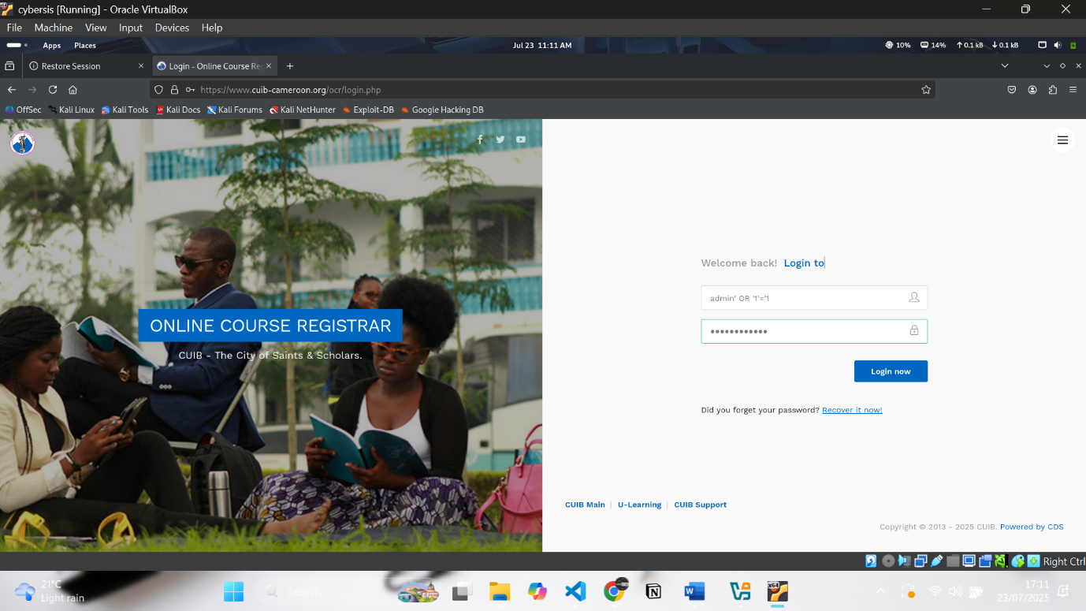

• admin' –
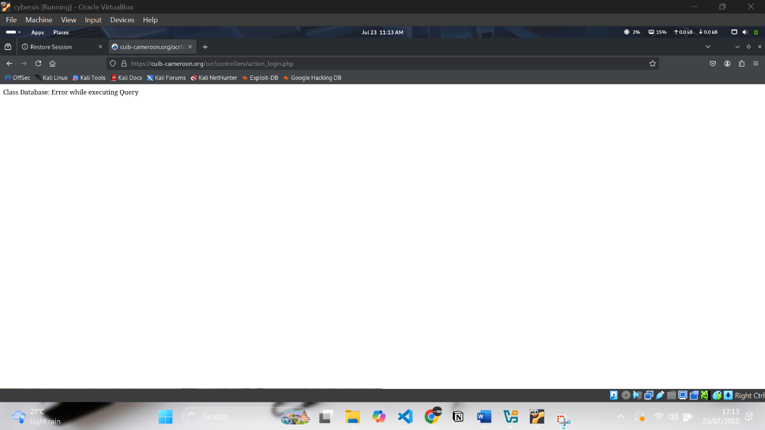
• admin' OR 1=1#
4. Intercepted the login POST request using Burp Suite and saved it to a file named 'login.txt'.
5. Executed SQLMap using the command: sqlmap -r login.txt --level=5 --risk=3 --batch --dump
6. Performed blind/time-based SQL injection checks using: sqlmap -r login.txt --technique=T --time-sec=5

3. Results
Initial manual SQLi tests on the email input did not return any obvious SQL errors or bypass the login, indicating some level of input sanitization. However, the use of time-based payloads caused a noticeable delay in response from the server, suggesting that the backend is executing the SQL query and potentially vulnerable to time-based blind.
SQLMap further supported this by attempting to enumerate databases and indicating the possibility of injection points based on timing and behavior analysis.SQL injection.
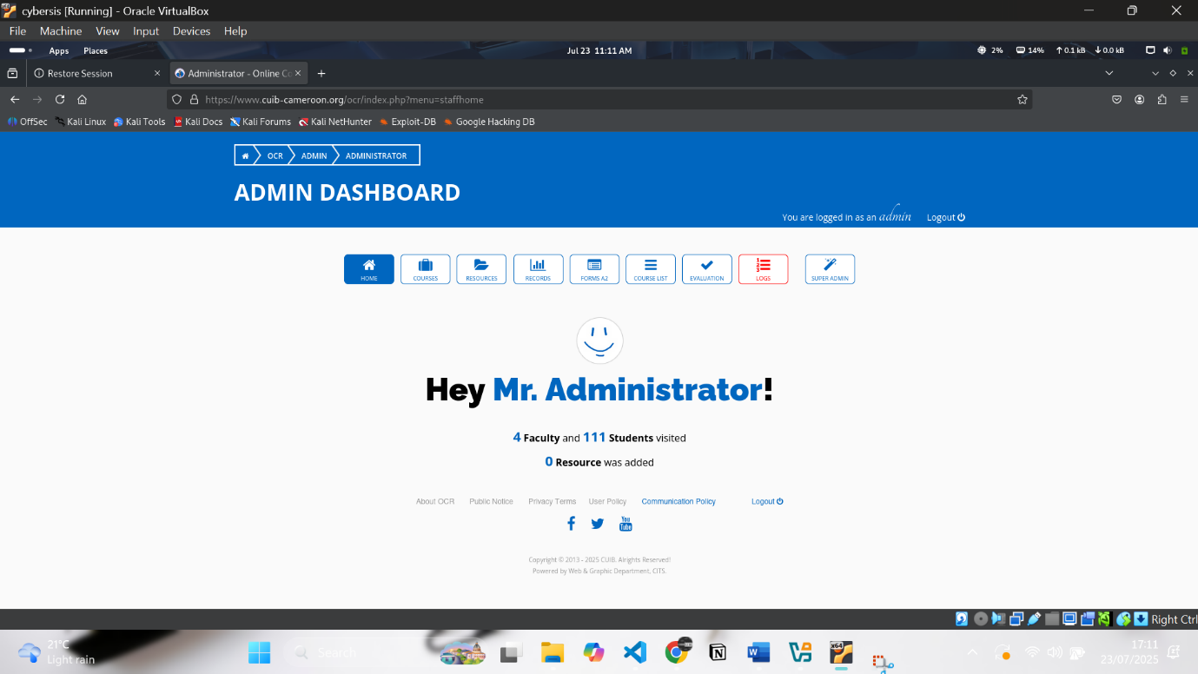

Got administrative access to the website


It Displayed the error which shows the site is vulnerable to SQL injection

4. Recommendations
• Implement prepared statements (parameterized queries) to eliminate SQL injection risks.
• Apply input validation and sanitization on all fields, particularly those interacting with the database.
• Introduce a Web Application Firewall (WAF) to help detect and block SQL injection attempts.
• Conduct periodic security testing including automated scans and code reviews.
•Provide training for developers on secure coding practices.

5. Conclusion
Although the site appears to have basic protections in place, the delayed response to time-based SQL payloads indicates a potential vulnerability to blind SQL injection attacks. Further investigation and patching are required. The security team is advised to thoroughly audit the backend code and apply mitigation techniques as recommended.

